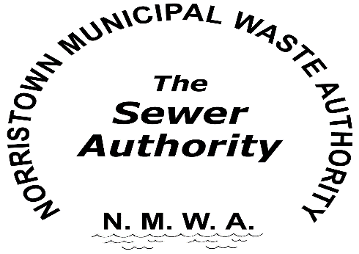
Sewer Certification Request Form
To certify that all sewer fees owed to Norristown Municipal Waste Authority have been paid in full, the following form must be completed and submitted to NMWA. There is a $35.00 fee payable in advance for the sewer certification. The check must be included with your request to process the certification.
Checks should be made to NMWA and mailed to 25 E. Marshall Street, Norristown PA 19401.
Please type or print clearly:

Property Address: ______________________________________________
______________________________________________
Seller’s Name: _______________________________________________
Buyers’ Name: _______________________________________________
Settlement Date: _______________________________________________
Parcel Number: ________________________________________________

Requestor Information:
Company Name: _______________________________________________
Company Address: _______________________________________________
_______________________________________________
Contact Name: _______________________________________________
Phone Number: _______________________________________________
Fax Number: _______________________________________________
Email: _______________________________________________
Certifications take approximately one week from date of receipt.
25 E. Marshall Street Norristown, PA 19401 P (610)270-3190 FAX (610)270-3192

